Species Concepts and Speciation Assignment

Reproductive Isolation Mechanisms

For each example below, decide which reproductive isolation mechanism is involved. Explain your answer.

1. Female sticklebacks will only mate with males that have certain characteristics
and behaviors, including:
♦ Male must have a bright red color on his front, just under his head
♦ Male must have a territory with a nest of algae and water plants
♦ Male must approach female and do a proper “zig-zag” dance

2. Two species of sages, white sage (Salvia apiana) and black sage (S. mellifera),
occur in the sage community of California.

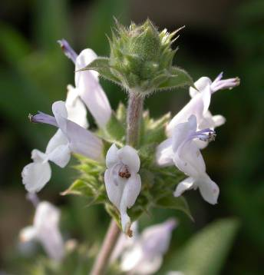
Black sage flowers are small and tube-shaped. Their flowers are pollinated by at least 13 different animals, including small and medium-sized insects.

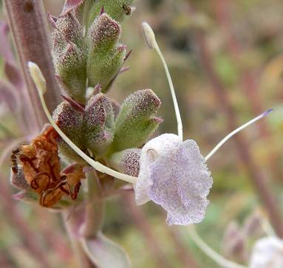

The white sage flowers are shaped very differently, with a greatly extended lip. The stamens and styles are extremely long and wide set. Only four species of very large bees are known to pollinate white sage flowers.

Because of the differences in flower shape, pollinators of white sage flowers
cannot pollinate black sage flowers. Pollinators of black sage flowers are too
large to pollinate white sage flowers.

3. The Traill's Flycatcher was originally considered to be one species with two song
forms: Fee-bee-os and Fitz-bews. Individuals of both song types are virtually
identical and cannot be distinguished by their appearance. The Fee-bee-os were
found only around stream and lake edges in wooded areas. The Fitz-bews were
found only around stream and lake edges in grassland areas. Also, the Fitz-
bews showed definite nesting preference for willow and rose shrubs while the
Fee-bee-os showed no nesting preference. When tape recordings of the songs
were played to the birds, they only responded to the songs of their own types.
Fee-bee-os only responded to Fee-bee-o songs; Fitz-bews only responded to
Fitz-bew songs.

In 1963, Stein discovered these differences and proposed that the two forms be
considered as sub-species of the Traill's Flycatcher. Today, ornithologists
recognize them as separate species. The Fee-bee-os are now called Alder
Flycatchers (Empidonax alnorum). The Fitz-bews are now called Willow
Flycatchers (E. traillii).

4. Carolina yellow jasmine (Gelsemium sempervirens) and swamp yellow jasmine (G.rankinii) are both found in Georgia. While the flowers of both plants look
identical, the swamp yellow jasmine flowers have no smell and their leaves are larger. Both flowers are pollinated by the same pollinators, especially apid
bees. Cross-pollination between the two plants rarely occurs. Carolina yellow
jasmine begins to flower in mid-February, peaks in late February through early
March, and finishes in mid to late March. Swamp yellow jasmine begins to flower
in late March, peaks in early April and finishes in mid-April.

When cross-pollinated in greenhouses, neither plant will make very many fruits.
Few hybrid seeds will germinate. In the rare cases of hybrid seed germination,
all but one have died before flowering. The one hybrid that flowered did not
produce fertile seeds.

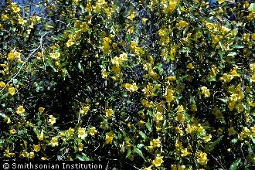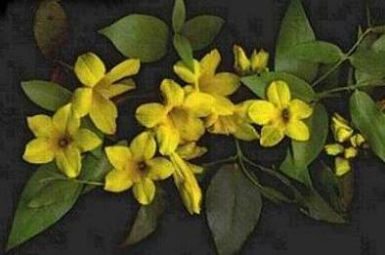
Gelsemium sempervirens Gelsemium rankinii
Photo Credit: R. A. Howard Photo Credit: Darryl Searcy,
@ USDA-NRCS PLANTS Database http://wildflowers.jdcc.edu

5. In Trinidad, the island is separated into three drainage basins by mountain
ranges. Male and female guppies (Poecilia reticulata) were taken from Caroni
and Oropouche drainage basins. There are no differences in appearance or
behavior between guppies in these drainage basins. Females were artificially
inseminated to make sure that mating occurred. Mating results are shown below.

 | Caroni Male | Oropouche Male
Caroni Female | Young produced | No young
Oropouche Female | No young | Young produced

6. When a male lion is crossed with a female tiger, the resulting offspring is a liger.
Ligers are larger than lions, with very pale tiger strips, and like to swim. Ligers
often thrive and live to old age. Male ligers are sterile. Female ligers can be
mated with tigers to produce offspring called ti-ligers. Although only a few ti-
ligers are known, the ti-ligers are often small and weak. The ones that have
survived to adulthood have not produced viable offspring.

Biological Species Concept

7. You are studying two populations of ground squirrels that live in neighboring geographic areas. Can you use the biological species concept to determine if
the two populations belong to the same species? Explain your answer.

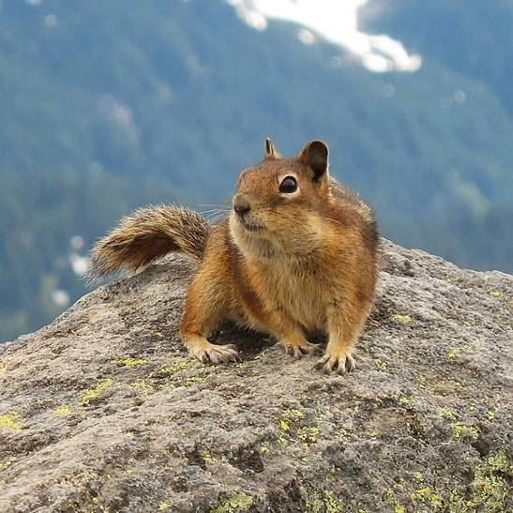
Photo Credit: K. Lee, Wikimedia Commons
http://commons.wikimedia.org/wiki/Media:Golden-Mantled_Ground_Squirrel,_Mount_Rainier,_July_2006.jpg

8. You are studying two strains of Streptococcus pneumoniae. One strain is
pathogenic and the other strain is not. Can you use the biological species
concept to determine if the two strains belong to the same species? Explain your
answer.

Biological Species Concept and Speciation

Go to this web page: http://evolution.berkeley.edu/evolibrary/article/_0_0/evo_40
and work through the section on speciation. Take these sidetrips:
- Biological Species Concept
- Speciation in Plants
- Ring Species

Once you are finished, answer these questions.

9. Define species.

10. Discuss the difficulties of identifying species.

11. Define speciation.

12. Discuss the difficulties of determining how speciation occurs.

13. Discuss several possible causes of speciation, including the special types of
speciation found in plants.

Case Study: The Salt Creek Tiger Beetle

Go to this web page: http://drshigley.com/lgh/sctb/default.htm
and click on the working links under "About the Beetles".

Once you are finished reading the material, answer the questions below.

14. If speciation is occurring in this group of beetles, what is the most likely mechanism?

15. Why is it important to try to conserve these beetles?

16. What are the greatest threats to the Salt Creek Tiger Beetle populations?

17. How likely is it that these populations will survive? Explain your answer.

